**Chapter 3**

**Derivatives**

**3.8 Implicit Differentiation**

**Section Exercises**

**For the following exercises, use implicit differentiation to find **

301. 

Answer: 

303. 

Answer: 

305. 

Answer: 

307. 

Answer: 

309. 

Answer: 

**For the following exercises, find the equation of the tangent line to the graph of the given equation at the indicated point. Use a calculator or computer software to graph the function and the tangent line.**

311. **[T]** 

Answer:

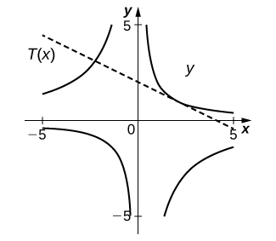



313. **[T]** 

Answer:

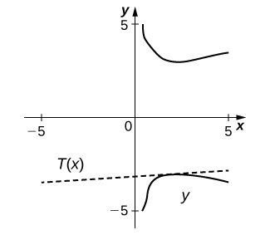



315. **[T]**  

Answer:

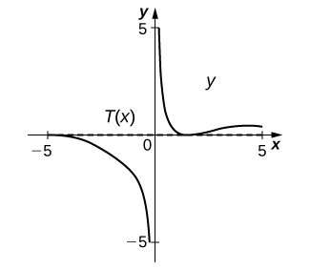



317. For the equation 

1. Find the equation of the normal to the tangent line at the point 
2. At what other point does the normal line in a. intersect the graph of the equation?

Answer: a. b. 

319. For the equation 

1. Find the -intercept(s).
2. Find the slope of the tangent line(s) at the *x*-intercept(s).
3. What does the value(s) in b. indicate about the tangent line(s)?

Answer: a.  b.  c. They are parallel since the slope is the same at both intercepts.

321. Find the equation of the tangent line to the graph of the equation  at the point 

Answer: 

323. **[T]** The number of cell phones produced when  dollars is spent on labor and  dollars is spent on capital invested by a manufacturer can be modeled by the equation 

1. Find  and evaluate at the point 
2. Interpret the result of a.

Answer: a.  b. When $81 is spent on labor and $16 is spent on capital, the amount spent on capital is decreasing by $0.5926 per $1 spent on labor.

325. The volume of a right circular cone of radius  and height  is given by Suppose that the volume of the cone is  Find  when  and 

Answer: 

**For the following exercises, consider a closed rectangular box with a square base with side  and height **

327. If the surface area of the rectangular box is 78 square feet, find  when feet and  feet.

Answer: 

**For the following exercises, use implicit differentiation to determine  Does the answer agree with the formulas we have previously determined?**

329. 

Answer: 

This file is copyright 2016, Rice University. All Rights Reserved.